Test Case 1:

1. Place an order through Commerce Cloud
2. Go to shopping card and click on checkout button.

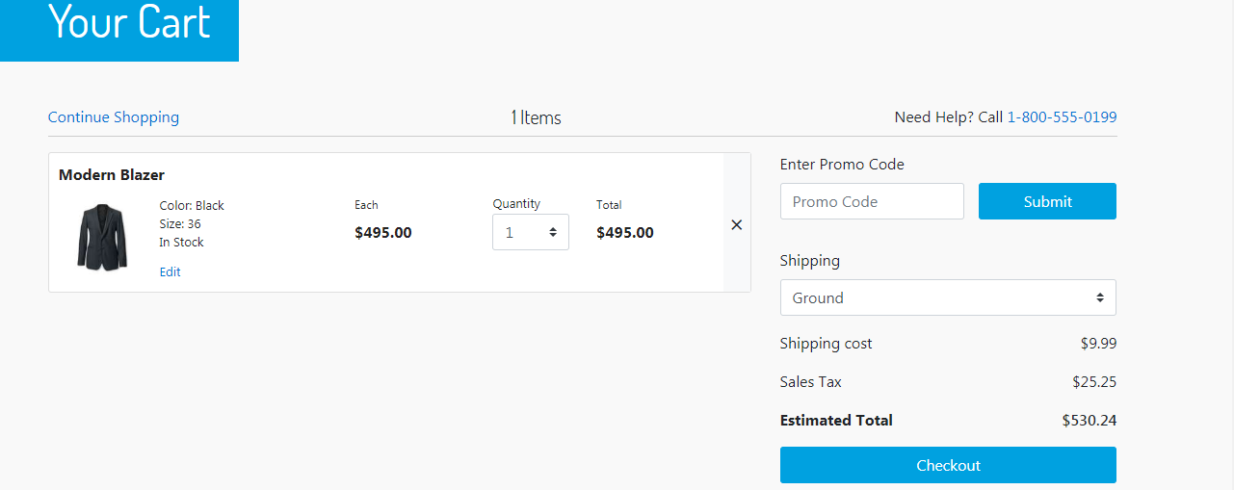

1. Fill in the address details, select the shipping method and click on payment button.

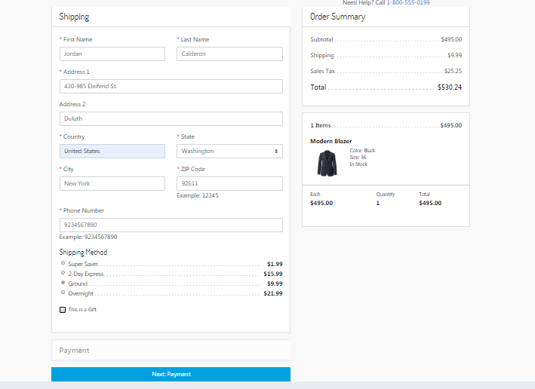

1. Enter the email and add card details. Click on Place Order button to place your order.

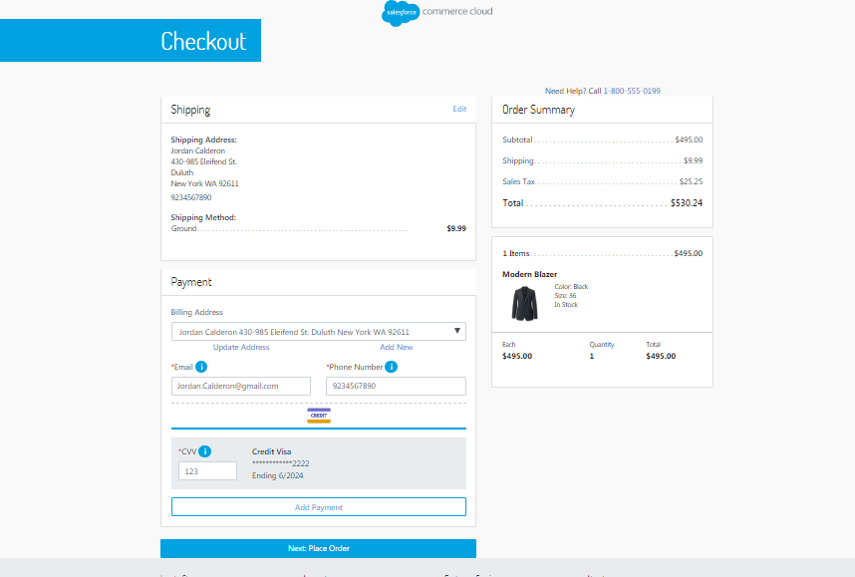

1. Verify the order shows up into Staging of GLOVIA OM
2. After placing the order from commerce cloud, order will show in GLOVIA OM with all the details populated from commerce cloud order.

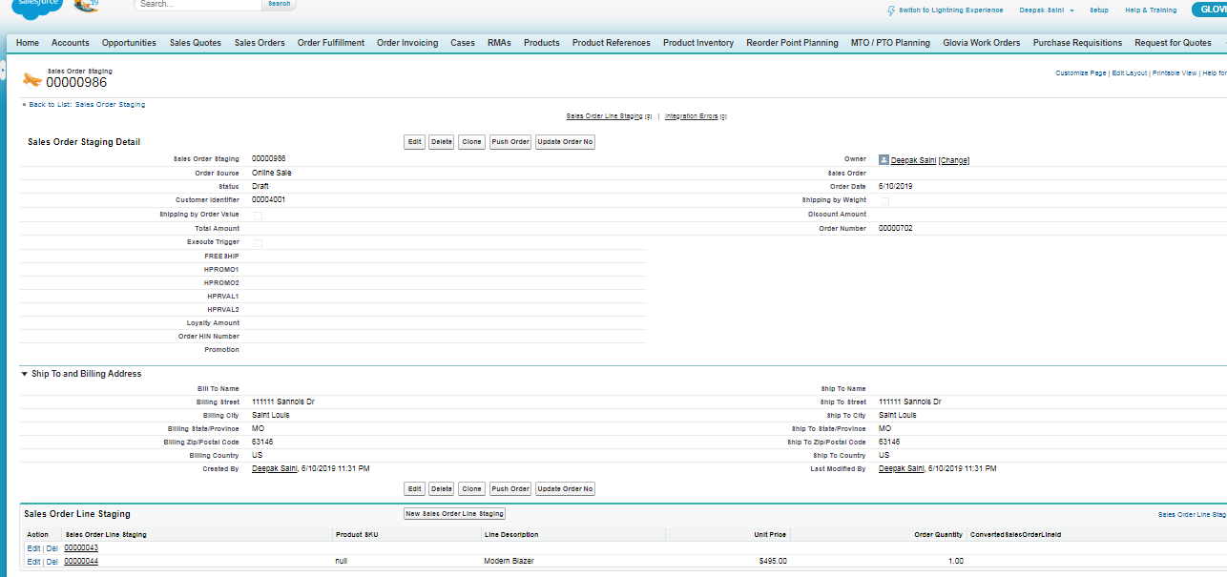

1. One Sales Order Line will be created with product details.

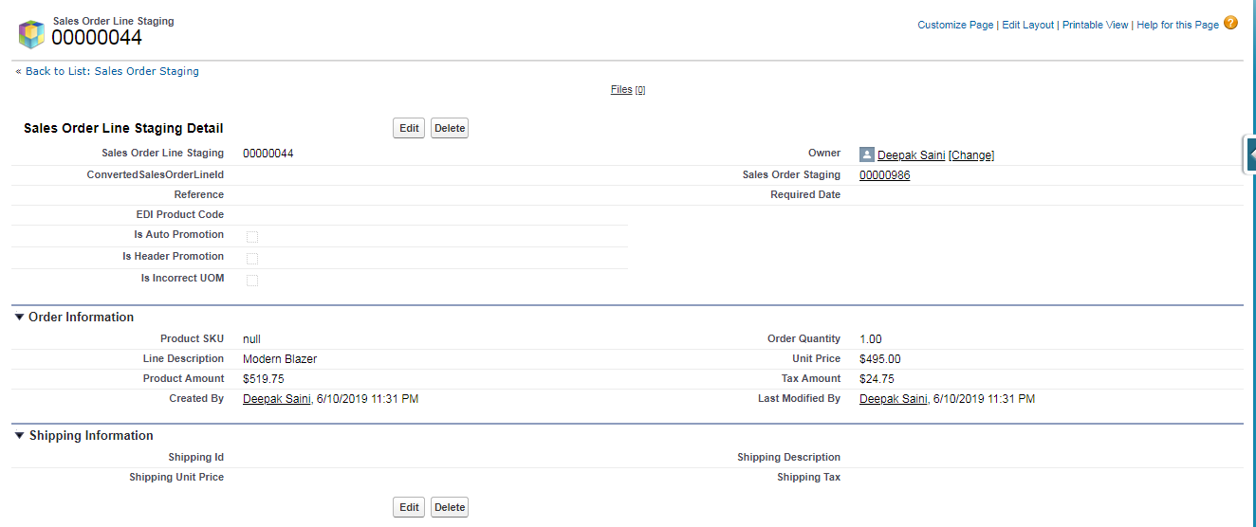

1. Second Sales Order Line will be created with Shipping Fees Details.

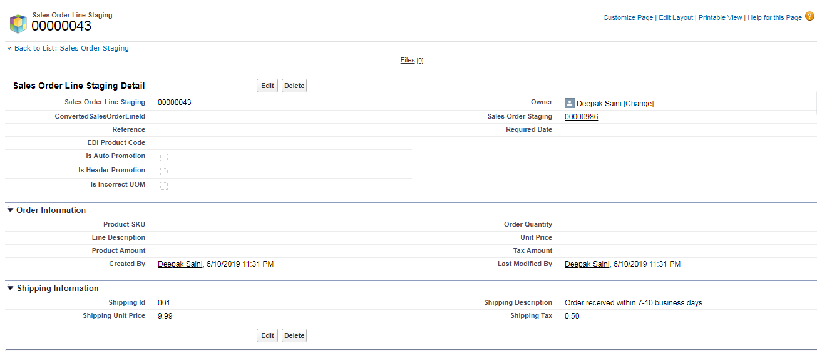

Test Case 2:

1. Make Patch from GLOVIA OM
2. Click on update order no button on the sales order staging record in GLOVIA OM. This will update the Sales Order Staging No on Commerce Cloud Order.

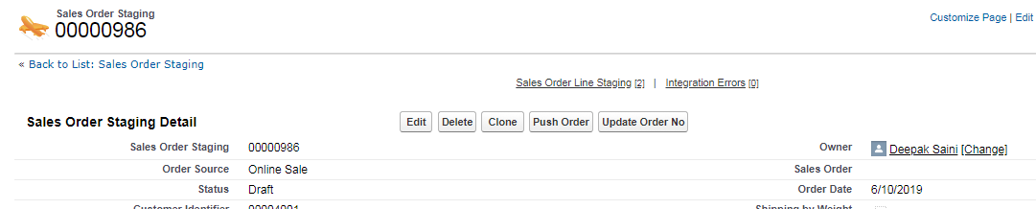

1. Verify the order shows up GLOVIA ORDER Number in External Order Number field into Commerce Cloud
2. The Sale Order Staging No from Glovia OM will be updated as External Order No in commerce cloud order.

